

**East West University**

**Department of Computer Science and Engineering**

**Course code :** CSE251;

**Course name : Electronic Circuits**

**Expt No : 1**

**Title : I-V Characteristics and Modeling of Forward Conduction of a Diode**

**Objectives:**

**1. To measure the I-V characteristics of forward conduction of a p-n junction diode.**

**2. To determine the models of forward conduction of a p-n junction diode.**

**Group-7**

**Group members**

**1.**

**2.**

**3.**

**4.**

1. **Md.Abu Zafor**

**ID:2020-2-60-158**

**Circuit Diagram:**

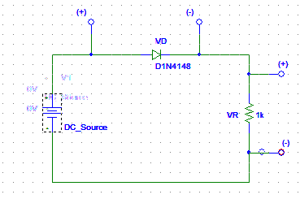

**Figure 1: Circuit set up to measure forward bias I-V characteristics of a diode.**

**Equipments and Components Needed:**

1. DC power supply

2. Digital multimeter

3. Diode (1 pc)

4. Resistor 1K

5. Breadboard

6. Connecting wires

**Table:01**

|  |  |  |  |
| --- | --- | --- | --- |
| **Vs(volt)** | **VD** | **VR** | **ID (mA)** |
| 0 | 0 | 0 | 0 |
| 0.1 | 0.1 | 0 | 0 |
| 0.2 | 0.2 | 0 | 0 |
| 0.3 | 0.3 | 0 | 0 |
| 0.4 | 0.4 | 0 | 0 |
| 0.5 | 0.5 | 0 | 0 |
| 0.6 | 0.497 | 0.103 | 0.103 |
| 0.7 | 0.523 | 0.177 | 0.177 |
| 0.8 | 0.540 | 0.251 | 0.251 |
| 0.9 | 0.554 | 0.345 | 0.345 |
| 1 | 0.565 | 0.435 | 0.435 |
| 1.5 | 0.599 | 0.900 | 0.900 |
| 2 | 0.62 | 1.380 | 1.380 |
| 2.5 | 0.635 | 1.865 | 1.865 |
| 3 | 0.646 | 2.354 | 2.354 |
| 3.5 | 0.656 | 2.844 | 2.844 |
| 4 | 0.664 | 3.336 | 3.336 |
| 4.5 | 0.671 | 3.829 | 3.829 |
| 5 | 0.677 | 4.323 | 4.323 |
| 5.5 | 0.683 | 4.817 | 4.817 |
| 6 | 0.688 | 5.312 | 5.312 |
| 6.5 | 0.693 | 5.807 | 5.807 |
| 7 | 0.697 | 6.303 | 6.303 |
| 7.5 | 0.701 | 6.799 | 6.799 |
| 8 | 0.707 | 7.295 | 7.295 |
| 8.5 | 0.709 | 7.791 | 7.791 |
| 9 | 0.712 | 8.288 | 8.288 |
| 9.5 | 0.715 | 8.785 | 8.785 |
| 10 | 0.718 | 9.282 | 9.282 |
| 10.5 | 0.72 | 9.78 | 9.78 |
| 11 | 0.72 | 10.28 | 10.28 |
| 11.5 | 0.73 | 10.77 | 10.77 |
| 12 | 0.73 | 11.27 | 11.27 |
| 12.5 | 0.73 | 11.77 | 11.77 |
| 13 | 0.73 | 12.27 | 12.27 |
| 13.5 | 0.74 | 12.76 | 12.76 |
| 14 | 0.74 | 13.26 | 13.26 |
|  |  |  |  |
|  |  |  |  |

**Post Lab questions answer:**

1. Using MATLAB, plot the I-V characteristics of the p-n junction diode in forward conduction. Label the axes appropriately and have it printed.

**Answer:**

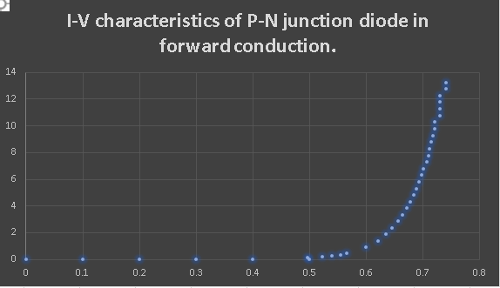

Fig: I-V characteristics of P-N junction diode in forward conduction.

2.Use pencil to identify the points on your graph that are corresponding to ID = 2mA and ID = 2.5mA. Use these data points to calculate the diode parameters IS and n from the equation ID = IS exp[VD/nVT]. Use VT = 0.0259V.

**Answer:**



Fig: I-V characteristics of P-N junction diode in forward conduction.

Here,

ID1 = 2.5, ID2 = 2, VD1 = , VD2 = and Vt = 0.0259

We know,

VD1-VD2 = Vtln($\frac{ID1}{ID2}$)

Again,

We know,

ID1= ISexp[VD1/VT]

=>IS=ID1/exp[VD1/VT]

=>IS=

=>IS =

3.Determine the cut-in voltage from the printed graph by drawing extrapolated line with pencil.

**Answer:**

4.If the diode resistance for the piecewise linear model is defined as 1/rD = әID / әVd =(ID2 – ID1)/(VD2 – VD1), calculate the value of rD from the data points corresponding to ID = 2mA and ID = 2.5mA.

**Answer:**

Here,

ID1 = 2.5 mA and VD1 =

And for

ID2 = 2.0 mA and VD2 =

we know,

1/ $r_{D}$ = (ID2- ID1)/( VD2- VD1)

So, the value of $r_{D}$ = ohm

**5.**Simulate the circuit of the figure 1 for a DC bias (VS) range of 0-5 volts using PSpice. Print the ID vs. VS and VD vs. VS plots generated by PSpice and attach them with your report. For simulation, use the DC SWEEP option of PSpice and the diode D1N4148. To modify the diode parameters, select the diode (it will turn red) and go to Edit Model

Edit Instance Model (Text). There, replace the values of IS, N, Vj by your values calculated in steps 2 and 3 and click OK.

**Answer:**

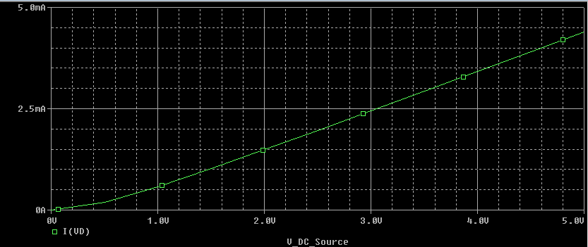

**Figure 1:ID VS VS graph**

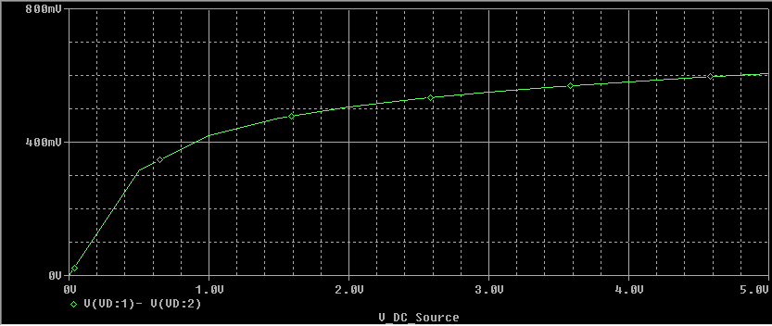

**Figure 2:VD VS VS graph**

**Conclusion:**

The V-I characteristics or voltage-current characteristics of the p-n junction diode is shown in the figure. The horizontal line in the below figure represents the amount of voltage applied across the p-n junction diode whereas the vertical line represents the amount of current flows in the p-n junction diode

An ideal diode, in forward conduction act like a short circuit but here in practical diode it consume some voltage to act like short circuit, but still it doesn’t act like short circuit fully because of leak voltage.